**AIDI2004 – Group 14 Assignment 3**

Based on the instructions, we had created a flask CRUD app. Website link here: <https://www.askpython.com/python-modules/flask/flask-crud-application> shows the code in which some tweaks or adjustments are made.

The following diagram shows the CRUD website.

**Create a Student’s name**

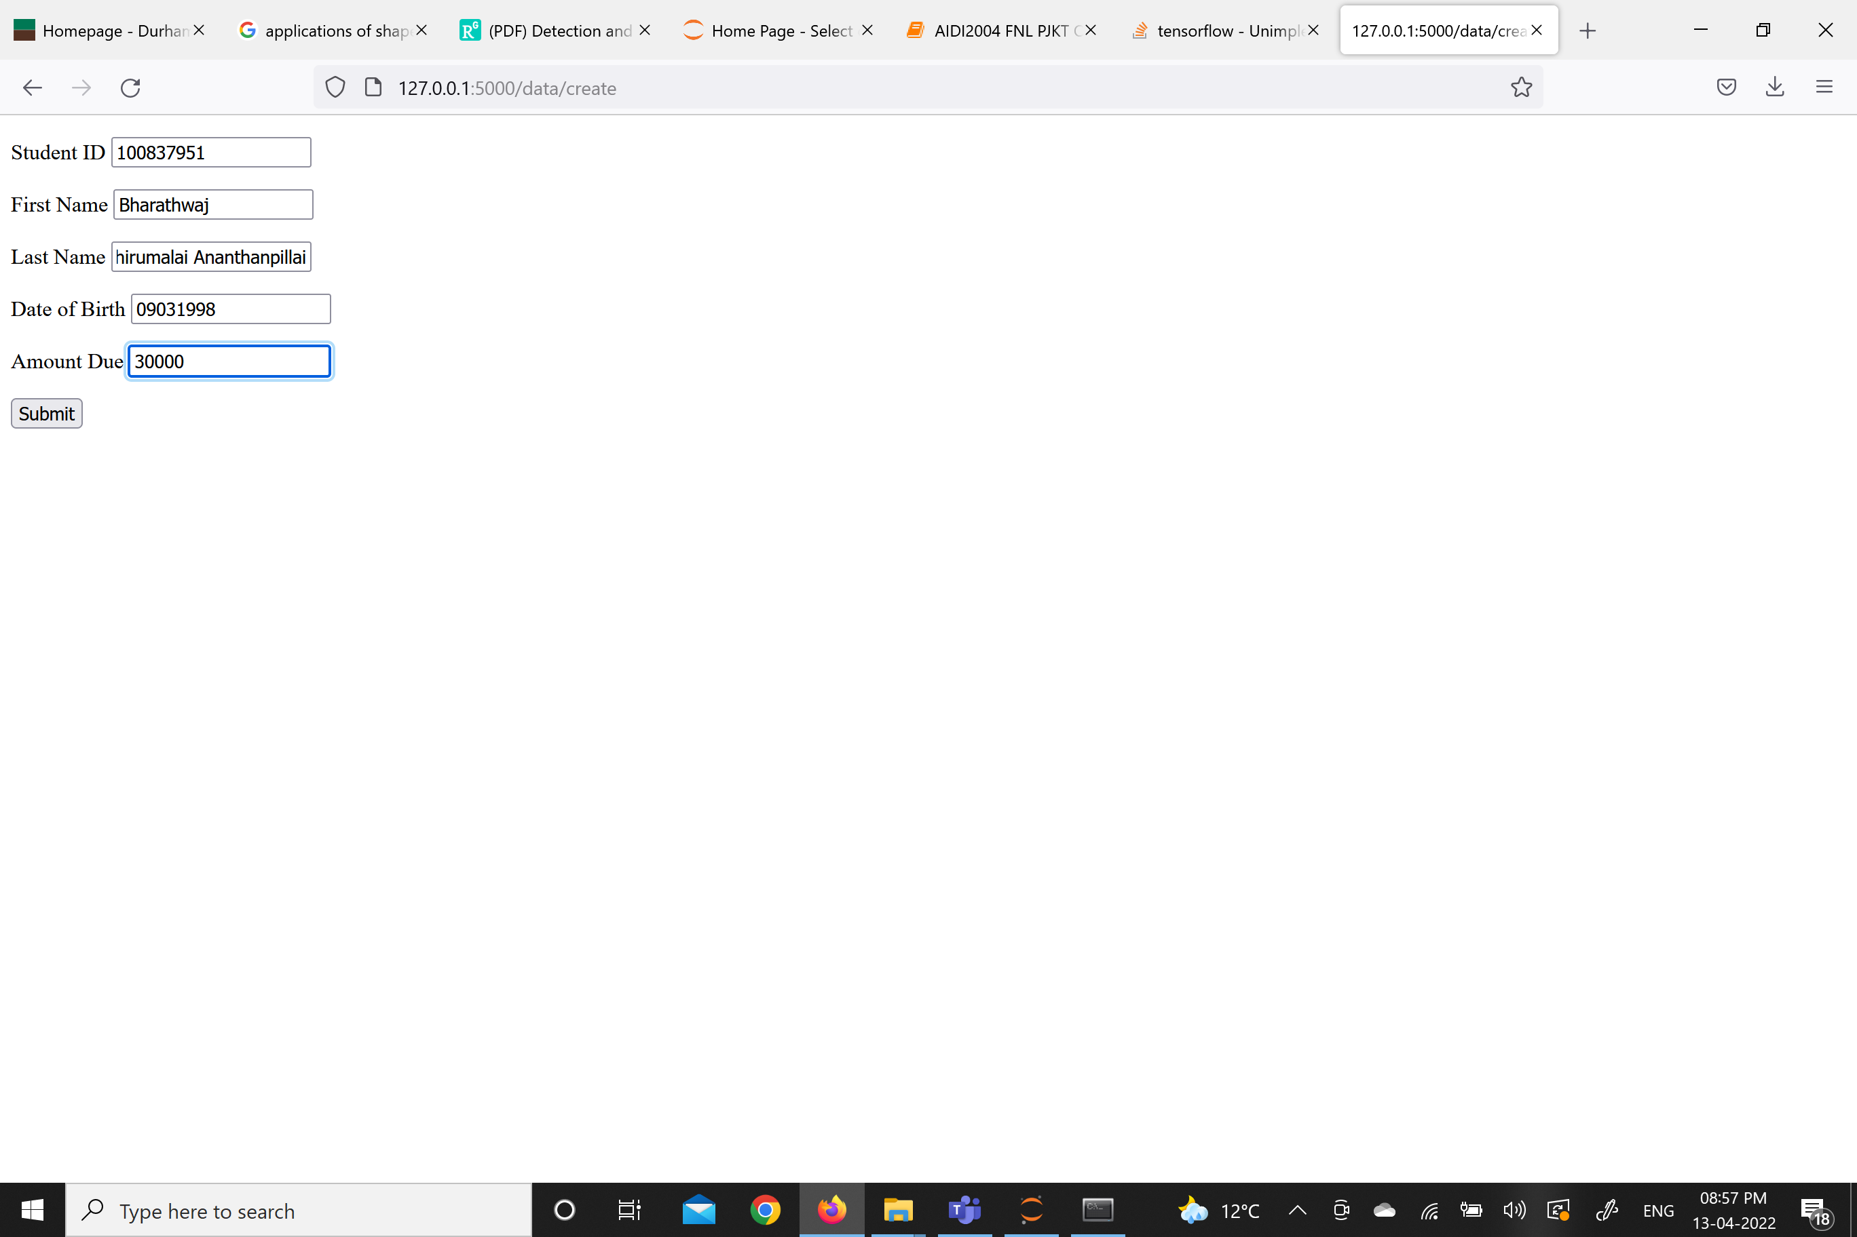

**Display of name**

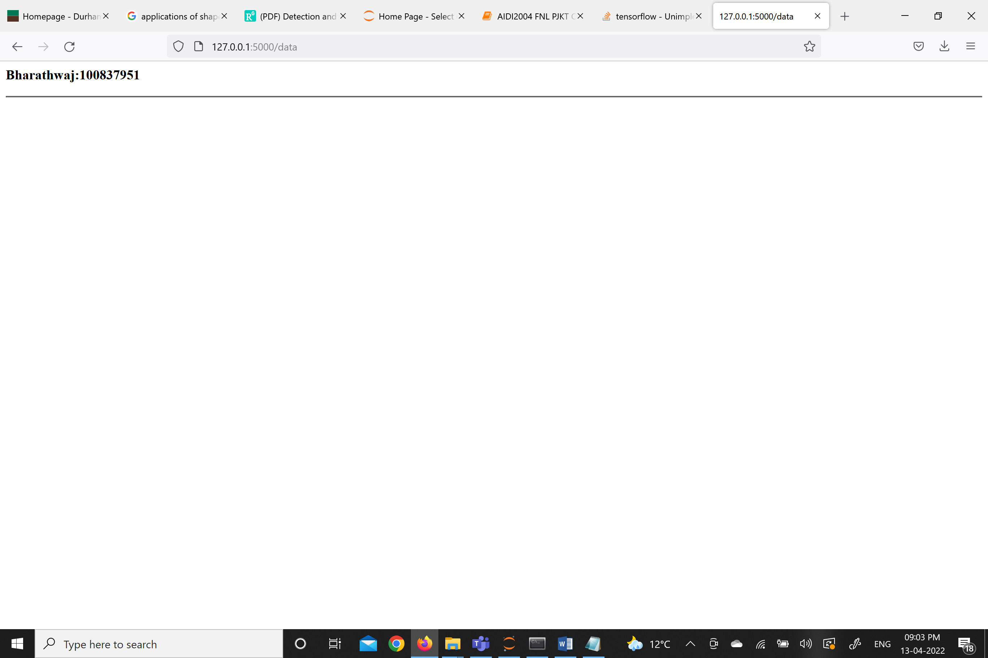

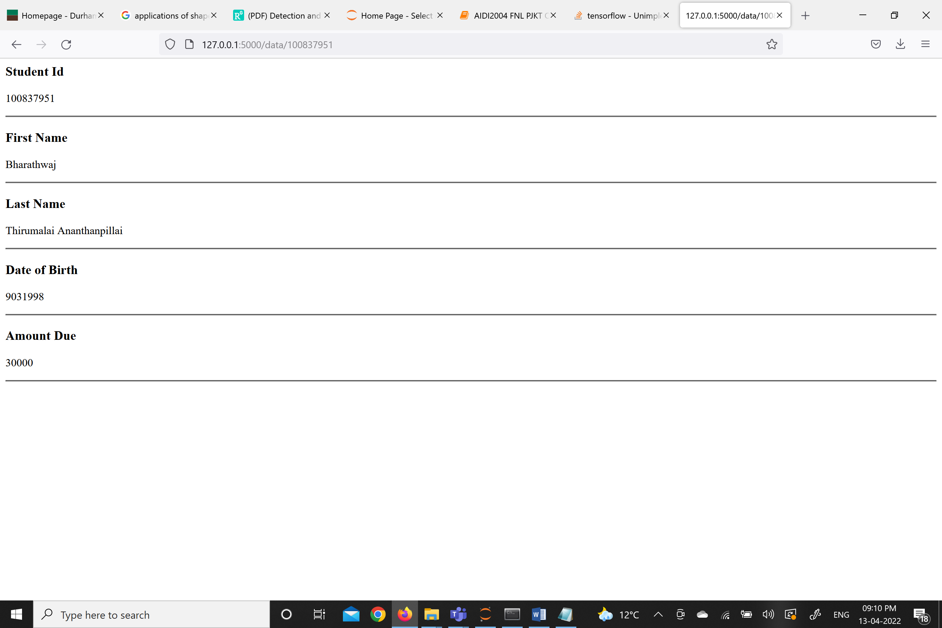

**Updating the data where we are changing the Amount Due from 30000 to 1000**

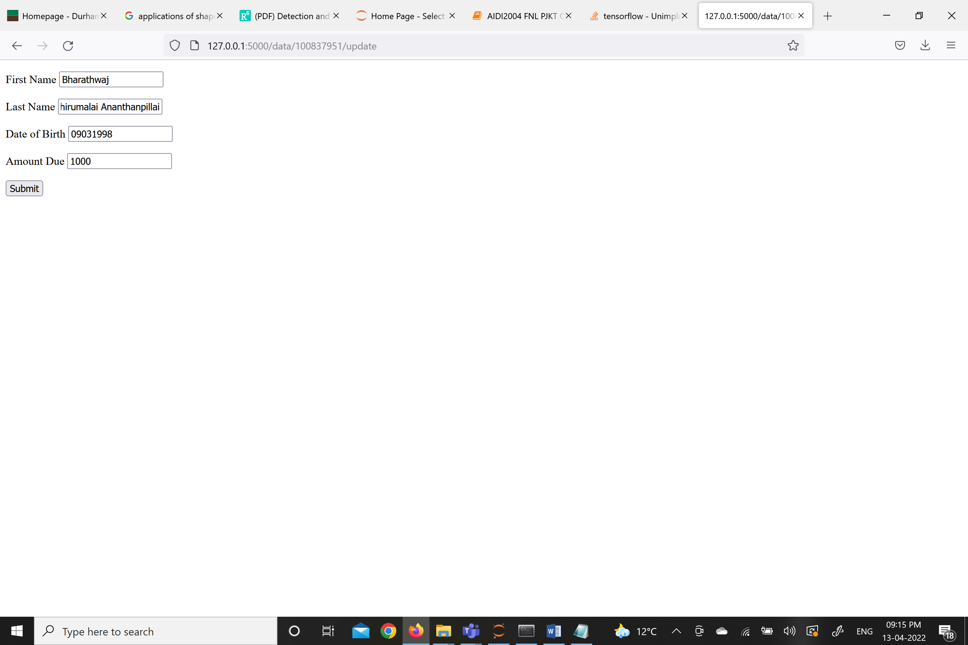

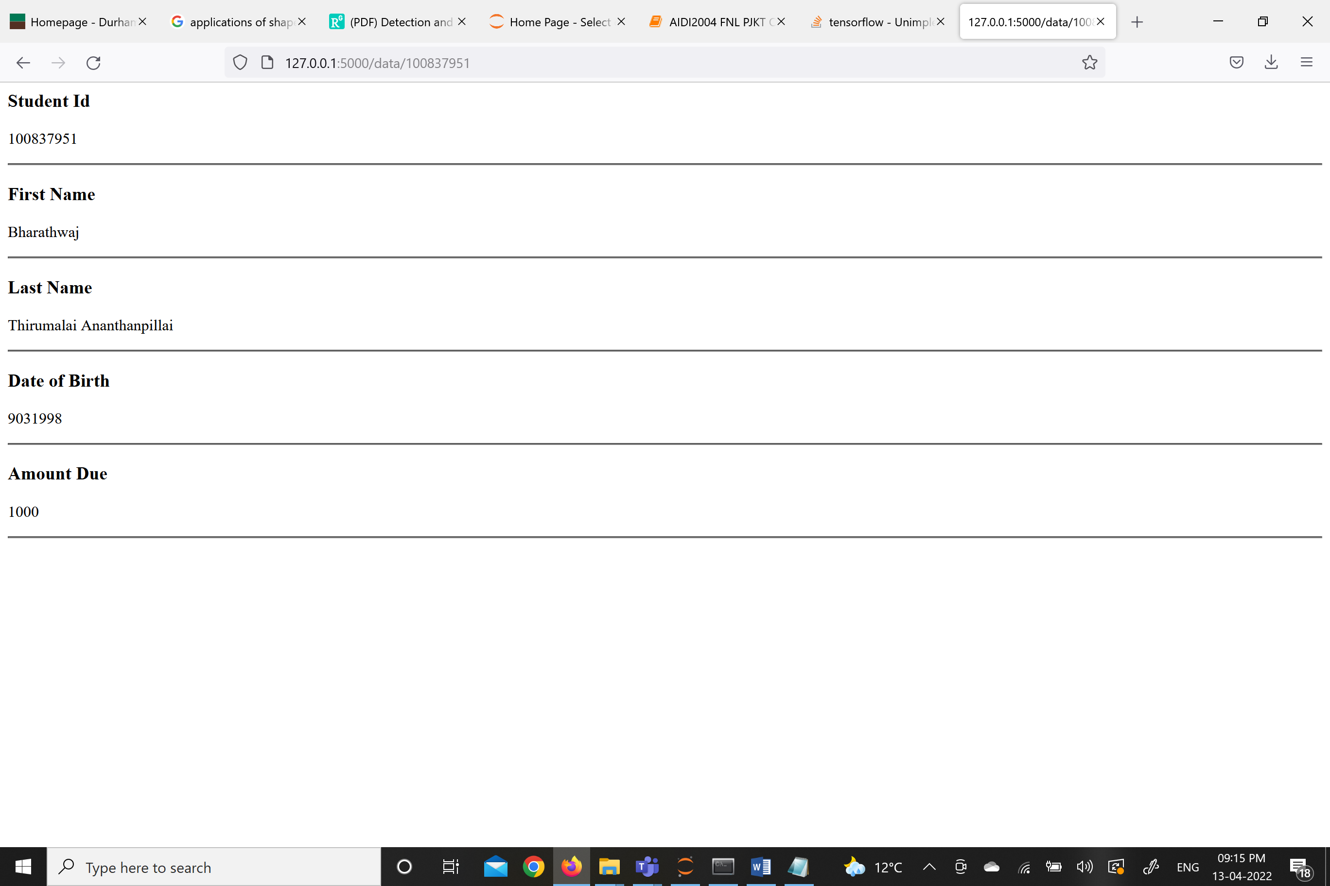

**Now we are going to delete this data as shown here**

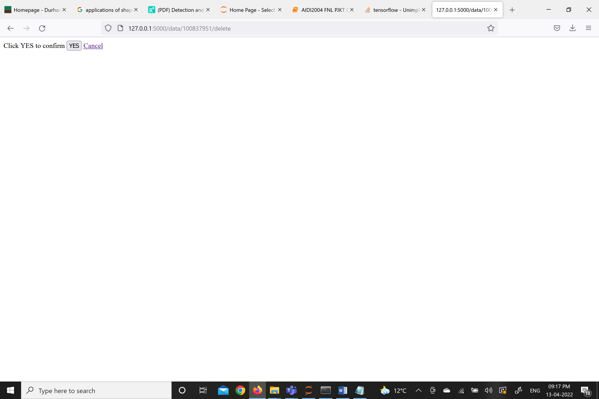

**After pressing Yes, the image below shows that the data entered is erased**

